|  |
| --- |
|  |
| Promotion Management  Overview & High Level Requirements for Phase 1 |
| 0.1 |

|  |
| --- |
|  |
| Authors: Andrew Jenkins  Date: 04/10/2017  Document Status : Initial version |

Table of Contents

1. Background 0

1.1. What is Trade Promotion? 0

1.2. Trade Promotion Virtuous Circle 0

1.3. Customer Needs 1

2. Solution 0

2.1. Needs - Solution Mapping 0

2.2. Solution Overview 0

2.3. Commercialization 0

2.4. Phased Implementation 0

3. Phase 1 – High Level Requirements 1

3.1. Business Domain 1

3.1.1. Promotion Management 1

3.1.2. Forecasting 1

3.1.3. Master Data 2

3.1.4. Promotion Definition/Data 2

3.2. Promotion Administration Features 3

3.2.1. Security 3

3.2.2. User Communication 3

3.2.3. Retailer forecast event schedule 3

3.2.4. Planned Promotion View 3

3.2.5. Create Promotion 3

3.2.6. View / Edit Promotion 4

3.2.7. Cancel promotion 4

3.2.8. View Promotion Schedule 4

3.3. Forecast Features 4

3.3.1. Reference Periods 4

3.3.2. View Forecast 5

3.3.3. Generate Forecast 5

3.3.4. Forecast Retailer V Store 5

3.3.5. Forecast Adjustment 5

3.3.6. Allocation 5

3.3.7. Shipment Order 5

3.4. General / Admin Features 5

3.4.1. Localization 6

# Background

## What is Trade Promotion?

**Trade Promotion** refers to marketing activities that are executed in retail between CPGs and Retailers.

Trade Promotion is a marketing technique aimed at increasing demand for products in retail stores based on:

* Special pricing
* Display fixtures
* Demonstrations
* Value-added bonuses
* No-obligation gifts
* ….and more.

## Trade Promotion Virtuous Circle

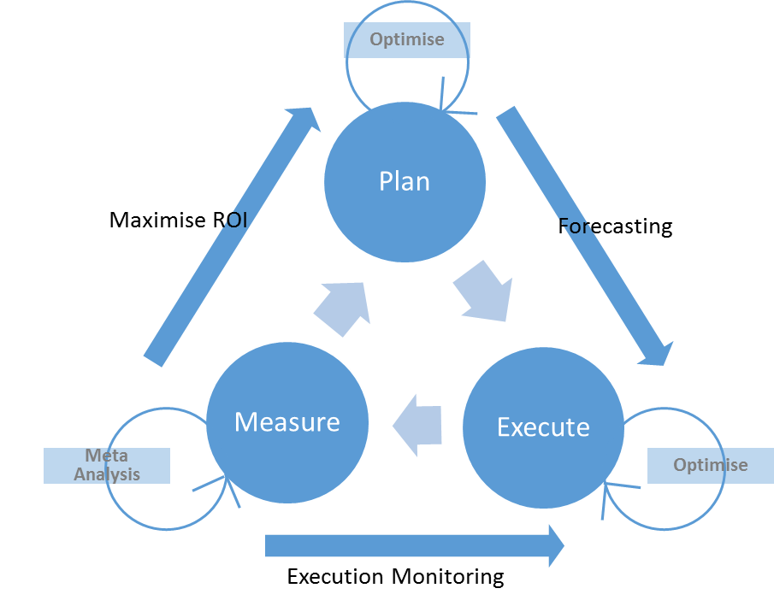

* Planning Promotions is optimized through analysis or previous promotion performance
* Planning and Analysis enable supply chain forecasting to reduce Lost sales from out of stock
* Measurement during promotion allows stock correction and validation promotion is being executed correctly
* Measurement confirms ROI

## Customer Needs

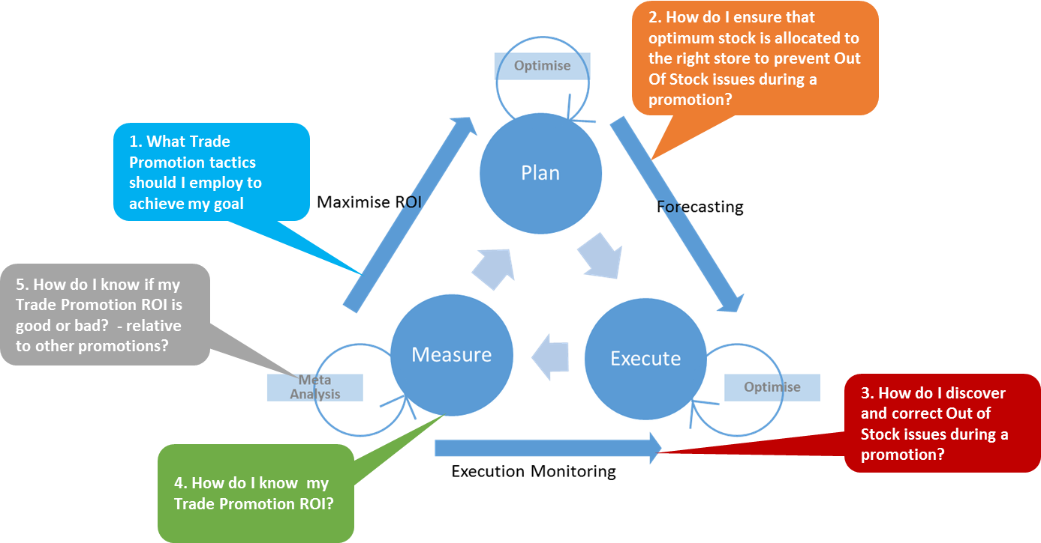

|  |  |  |  |
| --- | --- | --- | --- |
| **#** | **Problem Statements** | **Trade Promo Theme** | **Description/notes** |
| 1 | What Trade Promotion tactics should I employ to achieve my goal | - Planning and Optimisation  - Forecasting | Identification of how different tactics impact the success of a promotion |
| 2 | How do I ensure that enough stock is allocated to the right store to prevent Out Of Stock issues during a promotion? | - Execution  - Supply Chain  - Forecasting | Forecasting of promotion sales at store level based on previous promotions |
| 3 | How do I discover and correct Out of Stock issues during a promotion? | - Execution  - Supply Chain | Monitoring and Alerting of Out Of Stock during promotion |
| 4 | How do I know my Trade Promotion ROI? | - Measurement | Measurement of Promotion effectiveness |
| 5 | How do I know if my Trade Promotion ROI is good or bad? - Relative to other promotions? | - Measurement | Cross Promotion analysis and comparison |

# 

# Solution

## Needs - Solution Mapping

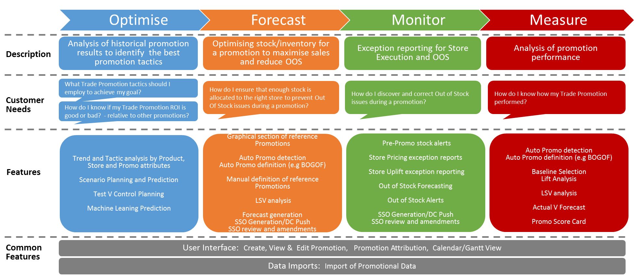

## Solution Overview

The promotion management solution will consist of 4 core modules plus a promotion admin UI

1. Optimize

The optimize module will allow CPGs to report across all their previously analyzed promotions to gain insight into the best promotion tactics for their products

1. Forecast

The forecast module will allow CPG companies to predict the amount of sales for a future promotion at a retailer and store level.

This will allow the CPG to ensure that enough stock is delivered to stores to support the promotion

1. Monitor

The Monitor Module will allow CPG companies to inspect the progress of their promotion whilst the promotion is running.

It will al provide exception reports for stores underperforming

1. Measure

The Measure Module will allow the CPG company to measure the performance of the promotion once the promotion has completed

1. Promotion Admin

Promotion administration shall allow user to view, create and edit promotion details

## Commercialization

* The modular design will allow CPG companies to purchase one or more modules.
* All deployments will included Promotion Admin
* “Navigation” for all modules should be present regardless of which modules have been purchased, however, functionality will be replaced by RSi marketing material
* RSi may consider on-site installations as well as hosted

## Phased Implementation

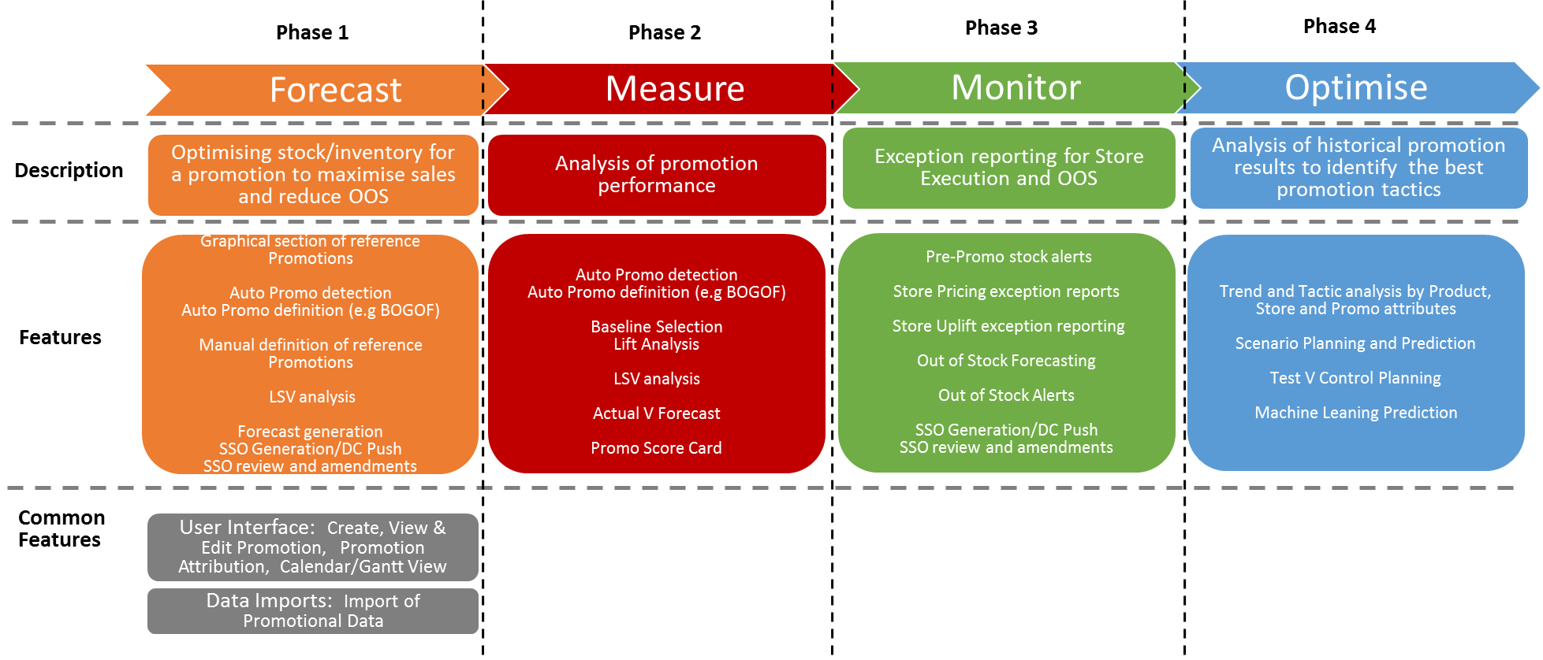

# Phase 1 – High Level Requirements

The following sections describe the high level requirements for:

* Promo Admin
* Forecasting Module

## Business Domain

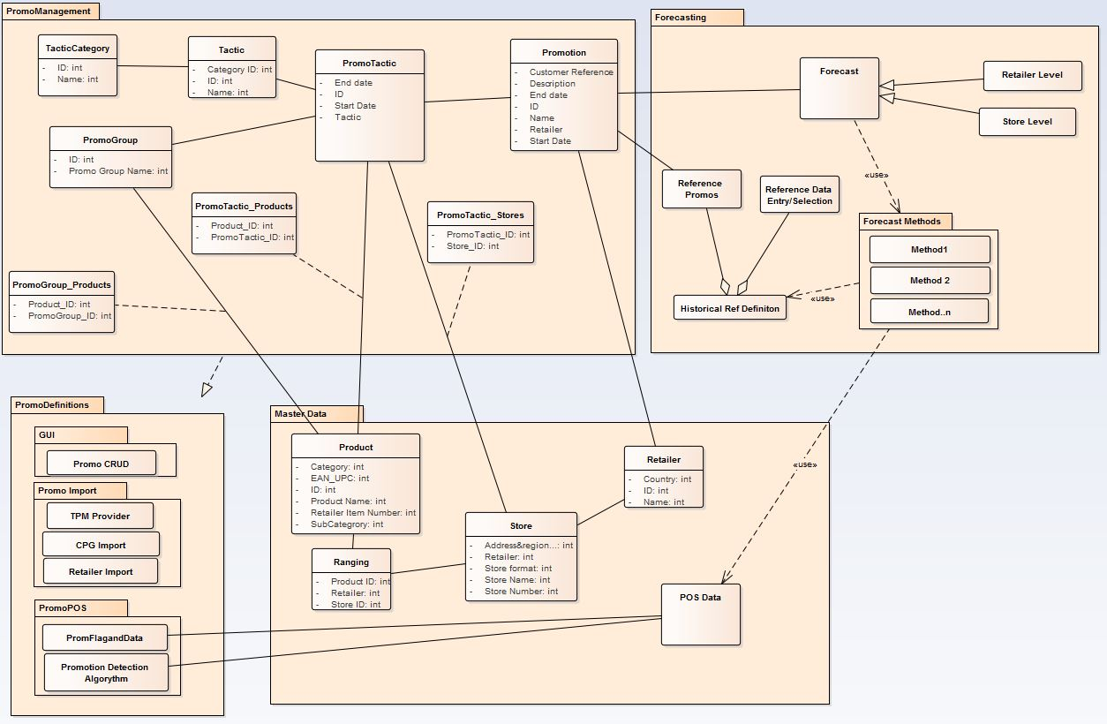

### Promotion Management

* Promotion

The Promotion Contains:

* + Name: name of the promotion
  + Description: textual description of what the promotion is and for
  + Start & End Date: when the promotion will begin and when it will end
  + Customer Ref: Customer’s own reference number
  + Retailer: which Retailer the promotion is for
  + Each promotion will have one or more PromoTactic
* PromoTactic

A PromoTactic describes a specific type of promotional activity, which product(s) that activity is for, which Stores where the promotional activity is taking place and what time period that activity is happening over. The specific promotional activity may not be for the entire promotion period

* + Tactic: the name of the promotional activity (% discount)
  + Tactic Category: e.g Temporary Price Reduction
  + Products(s): which product(s) have this specific PromoTactic
  + Stores: which stores this promotion tactic is occurring at
  + Start and end: when this specific PromoTactic will start and end
* Products and PromoGroups
  + Products may be assigned to a PromoTactic individually
  + Products may be assigned to a PromoTactic by PromoGroup. A PromoGroup is a set of products that are promoted together

### Forecasting

* Forecast

A forecast predicting the sales unit’s volume is generated for each product in the promotion

* + Retailer Level
    - A forecast can be generated a summary level per product for the retailer as a whole
  + Store Level
    - A forecast may be generated per product at the store level
* Historical Reference Period

The historical periods are used per product as the basis for predicting future sales. Typically this previous promotional periods

* + Historical Promotions
    - The user can specify historical periods by selecting previous promotions

* + Manual Entry
    - The can manually specify the dates or select from graphics of previous data
* Forecast Methods/algorithms
  + The forecast algorithm generates the forecast
  + Algorithms may vary between retailer, geography and CPG customer

### Master Data

* Products
* Stores
* Ranging
* Retailer
* POS Data

### Promotion Definition/Data

* Manual Creation
  + CRUD via GUI
* Data Imports
  + Retailer Promotion Calendar Import
  + CPG Import
  + 3rd Party Trade Promotion Management system import
* POS
  + Promo detection
  + POS Promotion Flag

## Promotion Administration Features

### Security

* Login
* Log Out
* Forgotten Password

### User Communication

* Welcome Message
  + Used for Adhoc messaging to users, such as for new features, releases, user guides etc
* Event/Time based notifications and emails
  + E.g Promotion X is 6 weeks from start – you need to do an initial forecast

### Retailer forecast event schedule

* Timings of when each kind of report/ action should be done
* Should vary by retailer
* E.G
  + 6 weeks before Promo – generate Retailer Level Forecast
  + 4 weeks before Promo - generate Store Level Forecast
  + Etc

### Planned Promotion View

* List of all upcoming promotions
* User can select a promotion to view, edit and create forecast for

### Create Promotion

* Promotion Details
  + Name, reference, dates, description, etc
* Products
  + Autocomplete on
    - Retailer Item Number
    - Barcode (EAN/UPC)
    - Product Name
  + Product Search
    - Search for products by
      * Name
      * Category
      * Brand
      * Promotion Group
    - Select multiple products
  + Upload Product List, matching on
    - Retailer Item number
    - Barcode(UPC/EAN)
  + Add PromoTactic (1 or more)
    - Select Tactic Category and Tactic
    - Select 1 or more Products
    - Assign stores
      * Upload list of stores matching on store number
      * Select stores based on attributes
        + Region
        + Format
        + etc
      * Select stores that the product(s) are ranged at
      * Combination of Store Attributes and Ranging
    - Assign dates

### View / Edit Promotion

As per create promotion

### Cancel promotion

* Allow user to cancel a planned promotion

### View Promotion Schedule

* View promotion schedule for past, current and future promotions
* Select Promotion to view/edit details and create forecast
* Filter by retailer / Promo Group / Product Category / Product
* Search for Promotion

## Forecast Features

### Reference Periods

* Historical Promotions
  + Allow user to view historical promotions for a product
  + Allow user to select historical promotions as the basis for reference periods
* Graphical Selection
  + View graph of average price and unit sales over time for a product
  + Allow user to select period(s) from the graph as reference period
* Upload Date ranges
  + Upload list of date ranges for products
* Manual Date selection
  + Allow a user to manually enter the date ranges per product
* Donor Products
  + Where a product is a new product and therefore has no sales history a substitute product’s sales history can used for reference

### View Forecast

* Forecast can be viewed online
* Forecast can be exported in excel
* Forecast can be published / shared online

### Generate Forecast

* System may support one more forecast methods
* Forecast method may be assigned per retailer-CPG
* Use may be given the option to select the forecast method

### Forecast Retailer V Store

* User is given the option to Forecast at the
  + Retailer level
  + Store Level

### Forecast Adjustment

* Adjust forecast
  + Total level
  + Store level

### Allocation

* Adjust allocation
  + Store attributes
  + Store promo tactics

### Shipment Order

* Generate stock shipment
  + Adjust for existing stock
  + Stock on order
  + Rate of sale

## General / Admin Features

### Localization

* Language Support
  + English UK
  + English US
  + Chinese
  + Brazilian Portuguese

### 